Java Statements

IF Statements
Executing code when one thing happens rather than something else is so common in programming that that the IF Statement has been developed. The structure of the IF Statement in Java is this:
if ( Statement ) {
}
You start with the word IF (in lowercase) and a pair of round brackets. You then use a pair of curly brackets to section off a chunk of code. This chunk of code is code that you only want to execute IF your condition is met. The condition itself goes between round brackets:
if ( user < 18 ) {
//do something
}

If the user is not less than 18 then the code between the curly brackets will be skipped, and the program continues on its way, downwards towards the last line of code. Whatever you type between the curly brackets will only be executed IF the condition is met, and this condition goes between the round brackets.
If you want to check for those who are 18 or over, you can say "greater than or equal to". The symbols for this are the greater than sign ( > ) followed by an equals sign ( = ):
if ( user >= 18 ) {
//DISPLAY MESSAGE
}
You can also check for "less than or equal to" in a similar way:
if ( user <= 18 ) {
//DISPLAY MESSAGE
}
Let's try all this out in a simple program.
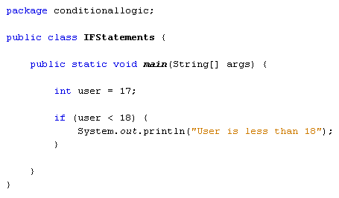
We've set up an integer variable, and assigned a value of 17 to it. The IF statement checks for "less than 18". So the message between the curly brackets should be printed out.
So the program runs OK, with no error messages. It's just that nothing gets printed out. The reason is that the message code is between the curly brackets of the IF Statement. And the IF Statement is checking for values less than 18. IF the condition is not met, Java ignores the curly brackets altogether and moves on.
Exercise
Replace your "less than" symbol with the "less than or equal to" symbols. Change your message to suit, something like "user is less than or equal to 18". Run your program again. Do you see the message?
Exercise
Change the user value to 20. Run your program again. Do you still see the message?
You can have more than one IF Statement in your code. Try the following code:
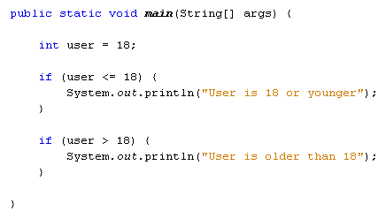
Instead of using two IF Statements, you can use an IF … ELSE Statement instead. Here's the structure of an IF … ELSE statement:
if ( condition_to_test ) {
}
else {
}
if (list == null) {
// This block of statements executes if the condition is true.
} else {
// This block of statements executes if the condition is false.
}
The if ... else statement is used to conditionally execute one of two blocks of statements, depending on the result of a boolean condition.
The first line starts with if, followed by the condition you want to test for. This goes between two round brackets. Again, curly brackets are used to section off the different choices. The second choice goes after the word else and between its own curly brackets. Here's our code again that checks a user's age:
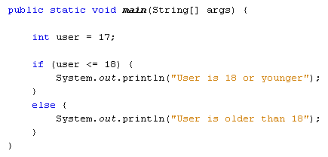
So there are only two choices here: either the user is 18 or younger, or the user is older than that. Adapt your code to match that in the image above and try it out. You should find that the first message prints out. Now change the value of the user variable to 20 and run the code again. The message between the ELSE curly brackets should display in the Output window.

IF … ELSE IF
You can test for more than two choices. For example, what if we wanted to test for more age ranges, say 19 to 39, and 40 and over? For more than two choices, the IF … ELSE IF statement can be used. The structure of an IF … ELSE IF is this:
if ( condition_one ) {
}
else if ( condition_two ) {
}
else {
}
The new part is this:
else if ( condition_two ) {
}
So the first IF tests for condition number one (18 or under, for example). Next comes else if, followed by a pair of round brackets. The second condition goes between these new round brackets. Anything not caught by the first two conditions will be caught be the final else. Again, code is sectioned off using curly brackets, with each if, else if, or else having its own pair of curly brackets. Miss one out and you'll get error messages.
Before trying out some new code, you'll need to learn some more conditional operators. The ones you have used so far are these:
> Greater Than
< Less Than
>= Greater Than or Equal To
<= Less Than or Equal To
Here's four more you can use:
&& AND
|| OR
== HAS A VALUE OF
! NOT
The first one is two ampersand symbols, and is used to test for more than one condition at the same time. We can use it to test for two age ranges:
else if ( user > 18 && user < 40 )
Here, we want to check if the user is older than 18 but younger than 40. Remember, we're trying to check what is inside of the user variable. The first condition is "Greater than 18" ( user > 18 ). The second condition is "Less than 40" ( user < 40). In between the two we have our AND operator ( &&). So the whole line says "else if user is greater than 18 AND user is less than 40."
We'll get to the other three conditional operators in a moment. But here's some new code to try out:
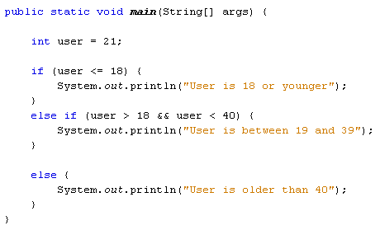
Run your program and test it out. You should be able to guess what it will print out before running it. Because we have a value of 21 for the user variable the message between the curly brackets of else if will display in the Output window.
Exercise
Change the value of the user variable from 21 to 45. The message for the else section of the code should now display.
You can add as many else if parts as you want. Suppose we wanted to check if the user was either 45 or 50. We can use two of the new conditional operators above. We can check if the user variable "has a value of 45" OR "has a value of 50":
else if (user == 45 || user == 50)
To test if the user variable has a value of something you use two equal signs, with no space between them. Java will test for that value and no other values. Because want to test for the user being 50 as well, we can have another condition in the same round brackets: user == 50. This just says "test if the user variable has a value of 50". In between the two conditions, we have the OR operator. This is two pipe characters, which is just to the left of the letter "z" on a UK keyboard. Again, there's no space between the two. The whole of the line above says "Else if the user has a value of 45 OR the user has a value of 50".
Here's our code with the new else if part:
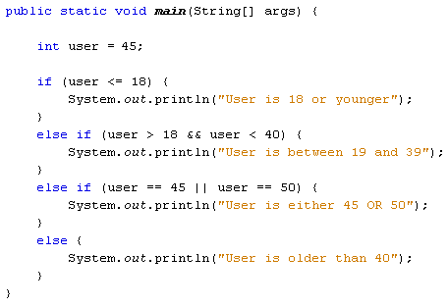
Try it out for yourself. Change the value of the user variable to 45 and run your code. Then change it to 50 and run the code again. In both cases the new message should display.
The various conditional operators can be tricky to use. But you're just testing a variable for a particular condition. It's simply a question of picking the right conditional operator or operators for the job.

Nested IF Statements
You can nest IF Statements. (This also applies to IF ... ELSE and IF ... ELSE IF statements.) Nesting an IF Statement just means putting one IF Statement inside of another. For example, suppose you want to find out if somebody is younger than 18, but older than 16. You want to display a different message for the over 16s. You start with the first IF Statement:
if ( user < 19 ) {
System.out.println( "18 or younger");
}
To check for over 16, you can place a second IF Statement inside of the one you already have. The format is the same:
if ( user < 19 ) {
if ( user > 16 && user < 19 ) {
System.out.println( "You are 17 or 18");
}
}
So the first IF Statement catches the user variable if it's less than 19. The second IF Statement narrows the user variable down even further, for ages over 16 and under 19. To print different messages, you can have an IF ... ELSE statement instead of the IF Statement above:
if ( user < 19 ) {
if ( user > 16 && user < 19 ) {
System.out.println( "You are 17 or 18");
}
else {
System.out.println( "16 or younger");
}
}
Notice where all the curly brackets are in the code: get one wrong and your program won't run.
Nested IF Statements can be tricky, but all you're trying to do is to narrow down the choices.
In the next section, you'll about the Boolean variable type. A Boolean value is one with two choices: true or false, yes or no, 1 or 0. In Java, there is a variable type for Boolean values:
boolean user = true;
So instead of typing int or double or string, you just type boolean (with a lower case "b"). After the name of you variable, you can assign a value of either true or false. Notice that the assignment operator is a single equals sign ( = ). If you want to check if a variable "has a value of" something, you need two equal signs ( = =).
Try this simple code:
boolean user = true;
if ( user == true) {
System.out.println("it's true");
}
else {
System.out.println("it's false");
}
So the first IF Statement checks if the user variable has a value of true. The else part checks if it is false. You don't need to say "else if ( user = = false)". After all, if something is not true then it's false. So you can just use else: there's only two choices with boolean values.
The only other conditional operator on our lists is the NOT operator. You can use this with boolean values. Have a look at the following code:
boolean user = true;
if ( !user ) {
System.out.println("it's flase");
}
else {
System.out.println("it's true");
}
It's almost the same as the other boolean code, except for this line:
if ( !user ) {
This time, we have our NOT operator before the user variable. The NOT operator is a single exclamation mark ( ! ) and it goes before the variable you're tying to test. It's testing for negation, which means that it's testing for the opposite of what the value actually is. Because the user variable is set to true then !user will test for false values. If user was set to false then !user would test for true values. Think of it like this: if something is NOT true then what is it? Or if it's NOT false then what?
Switch Statements in Java
Another way to control the flow of your programs is with something called a switch statement. A switch statement gives you the option to test for a range of values for your variables. They can be used instead of long, complex if … else if statements. The structure of the switch statement is this:
switch ( variable_to_test ) {
case value:
code_here;
break;
case value:
code_here;
break;
default:
values_not_caught_above;
}
So you start with the word switch, followed by a pair of round brackets. The variable you want to check goes between the round brackets of switch. You then have a pair of curly brackets. The other parts of the switch statement all go between the two curly brackets. For every value that you want to check, you need the word case. You then have the value you want to check for:
case value:
After case value comes a colon. You then put what you want to happen if the value matches. This is your code that you want executed. The keyword break is needed to break out of each case of the switch statement.
The default value at the end is optional. It can be included if there are other values that can be held in your variable but that you haven't checked for elsewhere in the switch statement.
If all of that is confusing, here's some code to try out. You can either start a new project for this, or just comment out the code you have. A quick way to comment out code in NetBeans is from the toolbar at the top. First, highlight the code you want to comment out. Then click the comment icon:
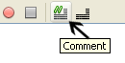
But here's the code:
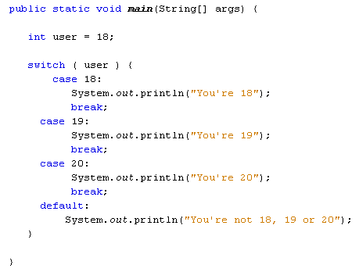
The first thing the code does is to set a value to test for. Again, we've set up an integer variable and called it user. We've set the value to 18. The switch statement will check the user variable and see what's in it. It will then go through each of the case statements in turn. When it finds one that matches, it will stop and execute the code for that case. It will then break out of the switch statement.
Try the program out. Enter various values for the user variable and see what happens.
Sadly, you can't test for a range of values after case, just the one value. So you can't do this:
case (user <= 18):
But you can do this:
case 1: case 2: case 3: case 4:
So the above line tests for a range of values, from 1 to 4. But you have to "spell out" each value. (Notice where all the case and colons are.)
To end this section on conditional logic, try these exercises.

Exercise C
Write a program that accepts user input from the console. The program should take a number and then test for the following age ranges: 0 to 10, 11 to 20, 21 to 30, 30 and over. Display a message in the Output window in the following format:
user_age + " is between 21 and 30"
So if the user enters 27 as the age, the Output window should be this:
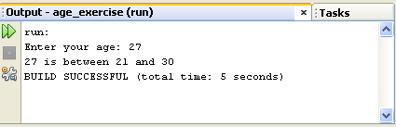
If the user is 30 or over, you can just display the following message:
"You are 30 or over"
Answer to Exercise C

Help for this exercise
To get string values from the user, you did this:
String age = user_input.next( );
But the next( ) method is used for strings. The age you are getting from the user has to be an integer, so you can't use next( ). There is, however, a similar method you can use: nextInt( ).

Exercise D
If you want to check if one String is the same as another, you can use a Method called equals.
String user_name = "Bill";
if ( user_name.equals( "Bill" ) ) {
//DO SOMETHING HERE
}
In the code above, we've set up a String variable and called it user_name. We've then assigned a value of "Bill" to it. In between the round brackets of IF we have the variable name again, followed by a dot. After the dot comes the word "equals". In between another pair of round brackets you type the string you're trying to test for.
NOTE: When checking if one string is the same as another, they have to match exactly. So "Bill" is different from "bill". The first has an uppercase letter "B" and the second has a lowercase "b".
For this exercise, write a program that asks a user to choose between four colours: black, white, red, or blue. Use IF … ELSE IF statements to display one of the following messages, depending on which colour was chosen:
BLACK "You must be a Goth!"
WHITE "You are a very pure person"
RED "You are fun and outgoing"
BLUE "You're not a Chelsea fan, are you?"
When your program ends, the Output window should look like something like this:
